EXL technical meeting, NuSTAR week 2012, GSI 02-03-2012
Participants:
KVI: M. Lindemulder, C. Rigollet, P. Schakel, N. Kalantar, A. Najafi, S. Bagchi, M.N. Harakeh, B. Streicher
GSI: O. Kiselev, P. Egelhof, M. Mutterer, K. Yue, H. Weick, C. Scheidenberger, H. Simon, U. Popp, Y. Litvinov, T. Stöhlker, C. Kozhuharov
TUD: J.C. Zamora, M. von Schmid, T. Kröll
Uni. Edinburgh: P. Woods
PTI: V. Eremin
Uni. Frankfurt: N. Petridis
Riken: T. Yamaguchi
FAIR: V. Varentsov
The meeting, chaired by P. Egelhof, started at 14:00 and ended at 18:30.
The following items refer to the list of topics for the preparation of the EXL experiments, this document can be found in Annex 1 of the minutes. Due to a lack of time, not all items were discussed, only the most pressing ones.
- Beam schedule: as was discussed with the beam coordinator, the schedule could be as follows (to be confirmed): week 42: ⁵⁸Ni beam
week 43: ²⁰Ne
week 44: ⁵⁶Ni
Testing of the forward detector (pin diodes in UHV ) could be possible in week 20 (at night) with a Ti beam (400 MeV/u).
We would like to mount the EXL chamber in the ring in week 36 or week 37 at the latest. We shall keep in touch with the Atomic Physics group for an efficient operation.

- Target: The collaboration needs to buy the amount of H and He gases needed for the experiments.

Gas jet – Hydrogen 10¹³ cm⁻², diameter: 5 mm
Helium 10¹² cm⁻², diameter: 5 mm
The operation of the droplet target is not suitable at this stage.
The change from He to H is faster than the other way around because the temperature of He is lower than for H. The change of target takes a few hours.
The aperture placed at about 1 cm of the target should not pose a problem. If the slit were to cut the target, it would take a few minutes to restart.
U. Popp is responsible for connecting the target to the chamber.

- UNILAC/FSR: We can expect 5 10⁹ ⁵⁸Ni per spill; with a 42 mb cross section on the Be target, we would get 3.2 10⁵ ⁵⁶Ni per injection in the ESR. With a H target (10¹³ cm⁻²) and 2 MHz recirculation, the luminosity would be 6 10²⁴ cm⁻² s⁻¹. This does not include stacking!
Stacking was performed with a ²⁰Ne beam and was successful, although this is not a trivial operation. The stacking with a bunched beam should be discussed with the ESR group.
Regarding the change of beam from one week to another, this should pose no problem as both ⁵⁸Ni and ²⁰Ne are stable and are coming from the UNILAC. Only for ⁵⁶Ni do we need the FRS.
The contamination of ⁵⁶Ni by Cu and Co should be very small and not a problem for the experiment.
11. Equipment ²⁰Ne experiment: The pocket at 50 cm from the interaction point and on the beam side of the chamber will be used in coincidence with the forward detector in UHV for the ²⁰Ne experiment. Two DSSDs will be placed in the pocket for ΔE-E measurements, Edinburgh provides their own detectors and electronics. For this experiment, a separate DAQ will be used.
13. to 16. Detector pockets and infrastructure:
Cooling: The closing of the 90° big pocket may prove difficult when using ‘stiff’ pipes for the cooling. One solution could be to have a bellow-type device, which can be compressed to close the flange without putting stress on the Cu pipes. A second option could be to use stainless steel ‘flexible’ pipes to connect the Cu tubes to the feedthroughs (see Annex 2).
ASICs: it has been decided to use the ASICs outside the pocket for the experiments. We will also have a backup system in case of problems with the ASICs (Mesytek electronics).
M. Lindemulder will design a holding mechanism for holding the ASICs outside of the pocket.
The lower threshold of the ASICs should be measured.
Connectors, cabling and feedthroughs for the DSSDs have to be ordered (see Annex 3), after some tests such as outgassing and spring pinning of the cables. GSI will order the equipment.
The vacuum system will be separated from the flanges containing feedthroughs to reduce the noise background and we will keep some blind flanges in case we need to add more feedthroughs. M. Lindemulder will update the technical drawings.
A copy of the DSSD head will be manufactured for the second pocket (covering 26.7° to 37.5° in the LAB frame).
Thermal tests of the EXL chamber: H. Timersma (KVI) will go to GSI (probably in week 11) to prepare the chamber and vacuum equipment before the baking.
10. Aperture: the distance of the aperture when in an out-position is 6 cm and largely sufficient not to perturb the beam tuning or the target. Several designs are being considered (M. von Schmid, M. Lindemulder and O. Kiselev).
6. Vacuum system for big pocket: We wish to have a bypass with a valve monitoring automatically the pressure difference between the ring and pocket vacuums. The final agreement should be given by the ESR and Vacuum groups. See Annex 4.
23. Readout and electronics: one ASIC has been bonded. The test setup should be ready in April/May.

Summary of the meeting: two decisions have been made. We will use the ASICs outside of the pocket and a copy of the DSSD head will be manufactured.

The next VC meeting is planned on the 14th of March 2012.

Annex 1: Topics for Preparation of the EXL Experiment

 | Topic | Subtopic | When | Who
1 | coordination with beam coordinator |  | now until run | Peter, Nasser
2 | coordination with target and ESR groups |  | now until run | Peter, Nasser
3 | coordination with FRS group |  | now until run | Oleg, Peter
4 | preparation and installation of new chamber | coordination with  “Konstruktionsbüro”  and “Grossmontage” | now until September | Peter, Oleg
5 |  | organise space for preparation phase, installation at ESR | now until September | Peter, Oleg, Brano
6 |  | vacuum system, interlock,  baking,  coordination with vacuum group | now until June | Brano, Oleg, Harry,  Thorsten, Manfred
7 |  | luminosity monitor | until July | Mirko, Yue
8 |  | test alpha source | until September | Mirko, Oleg, Yue
9 |  | neutron detector | ??? | Nasser
10 |  | aperture in front of target including moving mechanism | now until July | Mirko, Juan, Peter, Oleg, Manfred, Michel, Catherine
11 |  | equipment for Phil Wood`s experiment | until September | Catherine
12 |  | final installation at ESR | September until October | Peter, Oleg, Brano, Manfred, Mirko, Thorsten, Yue + all KVI
13 | detector pockets including infrastructure | fabrication | 1st mid. Feb.  2nd ??? | Catherine + KVI workshop
14 |  | cooling | now until March | Brano, Manfred, Annelie, Harry
15 |  | cabling, feedthroughs, flanges, T-piece | now until May | Brano, Oleg, Manfred, Mirko, Yue  Thorsten, Michel, Peter S
16 |  | thermal tests | March until June | Catherine, Annelie, Brano, Oleg, Manfred, Peter, Mirko, Yue
17 | forward tagging detectors | preparation, baking,  position calibration, final test of moving mechanisms | now until February | Brano, Oleg, Harry
18 |  | detector for pockets  - Downstream  - EXL chamber right | now until June | Mirko, Thorsten  Catherine
19 |  | beam test at ESR | May ??? | Peter, Nasser
20 | detectors | DSSD setup and test | now until June | Brano, Manfred, Oleg, Mirko, Yue
21 |  | baking and vacuum tests | now until June | Brano, Manfred
22 |  | test of SiLi`s | now until June | Mirko, Brano, Oleg, Manfred
23 | readout and electronics | coupling capacitors | design until May | Brano, Oleg,  Manfred, Mirko
24 |  | cabling to preamps | design until May | Brano, Oleg, Manfred, Mirko
25 |  | ASICs | decision until May | Oleg, Mirko, Matthias, Peter S
26 |  | conventional electronics | May until June | Oleg, Mirko, Manfred, Thorsten, Yue
27 |  | electronics for SiLi`s | May until June | Mirko, Manfred, Oleg, Yue
28 |  | data aquisition, slow control | June until September | Mirko, Oleg, Yue
29 |  | cabling to ”Messhütte” | August until September | Mirko, Oleg, Brano, Yue, Ali, Soumya
30 | simulations | aperture design and performance | now until February | Mirko, Oleg,  Thorsten
31 |  | cross sections and count rates for (p,p), (p,p`), (α,α`) | now until March | Mirko, Oleg, Catherine, Nasser, Milano
32 | final setup and test |  | September until October | all

Annex 2: Swagelok flexible stainless steel tubing

321-4-X-12FMR ¼“, variable length, nominal – 12” (30 cm)

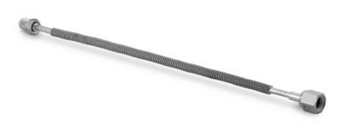

321-4-X-12DFR ¼“, variable length, nominal – 12” (30 cm)

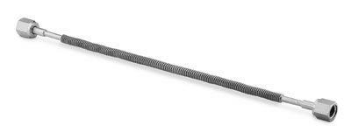
Price – 136 euro (30 cm)
321-4-X-12 ¼“, variable length, nominal – 12” (30 cm)

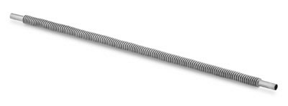

Price – 55 euro (30 cm)

Annex 3:
In-vacuum 50-pol cables

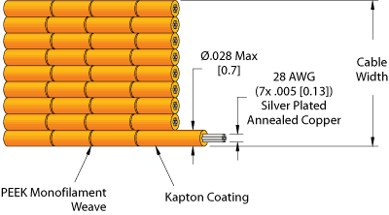

Kapton isolated, 2x25 wires, 0.9 mm diameter, 30 mm wide, 80 cm long

In-vacuum connectors – Sub-D, 50-pol, PEEK, bakeable up to 250 deg.

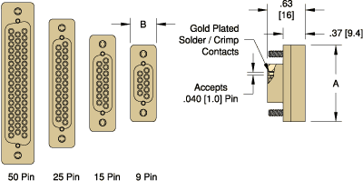

Price for cable + connector
Accu-Glass Instruments - 450 euro (from online-catalog)
Caburn MDC - 290 euro (offer 01.03.12)
CeramTec - 700 euro (offer 02.03.12)

Annex 4: 