VC KVI-GSI-TUD technical meeting 11-01-2012
O. Kiselev, M. von Schmidt, P. Egelhof, M. Mutterer, B. Streicher, M. Lindemulder, C. Rigollet, Th. Kroell, K. Yue, P. Schakel, N. Kalantar, H. Timersma, A. Kluttig

- Cabling: instead of using a 100-pins cable we will be using 2 50-pins cables. The electrical throughput can be made either by gluing the cable in a hole in the flange of by using a flange with connectors. Peter Schakel will check the price and delivery time for such a flange.
The majority of colleagues at GSI was against the solution with gluing.

- Thermal calculations: these were made to benchmark the experimental results obtain by Brano. The results are found to be in good agreement with each other. Energy transfer will be included in the final design.

- Pockets update: one in-ring pocket is ready and vacuum tested at KVI. Another window with a 25μm is ready and will be baked at KVI.
The design of pockets 2 and 3 (in the EXL chamber) has been discussed. Two solutions are envisaged (see figures 1 and 2) and although not the highest priority, having extra detectors at those positions would be an asset for the experiments.
For those detectors, two extra ASIC boards should be made and depending on the available electronics, some channels could be coupled. For the second solution (figure 2) UHV connectors should be used.

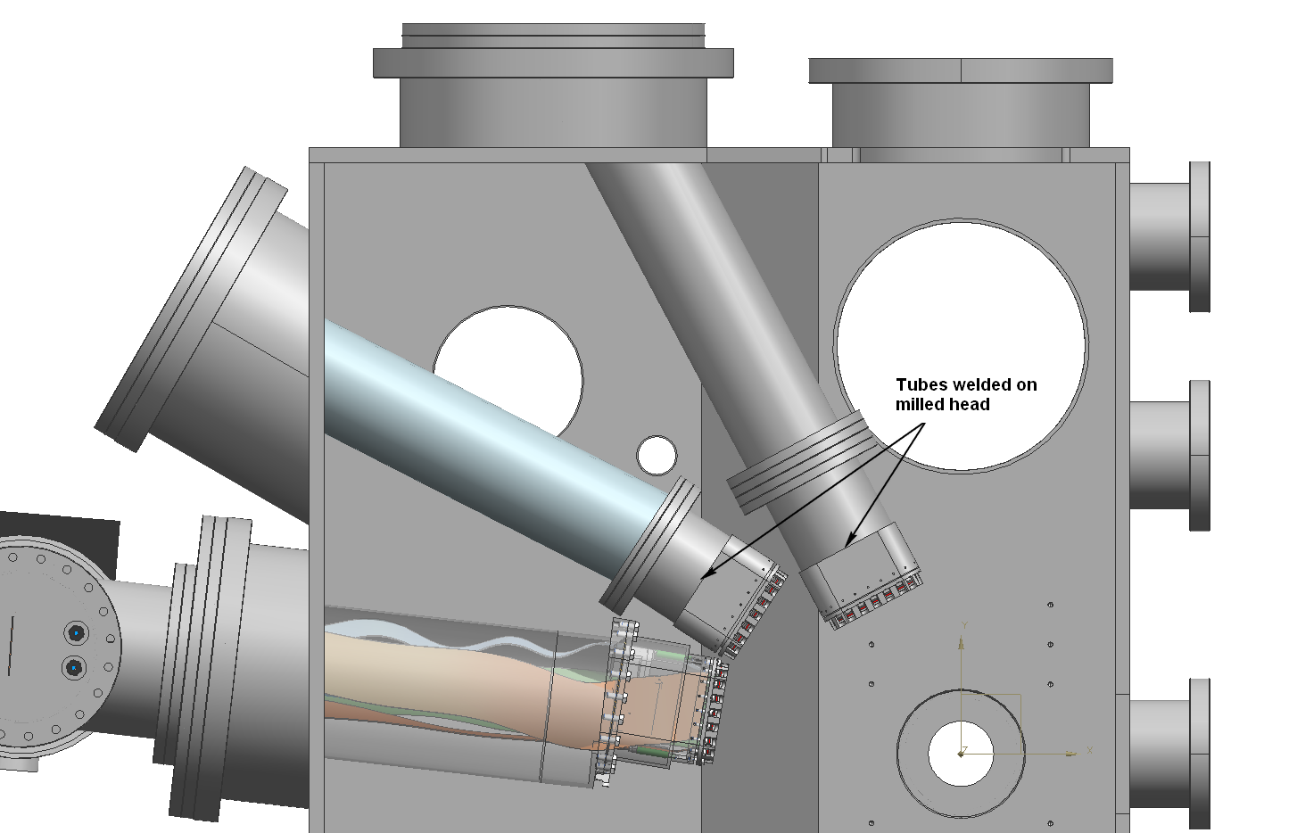
Figure 1: the DSSDs are mounted on heads similar to the one for the 90° pocket.
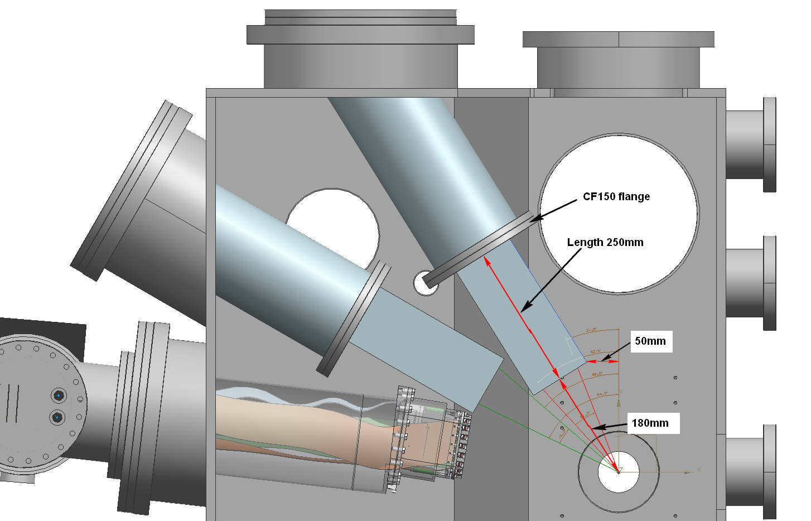
Figure 2: the DSSDs are mounted on a type of arm in UHV and connected to a pocket holding the electronics.

The 90° pocket will be ready and shipped to GSI before summer 2012. A thermal test with dummies will be done at KVI (up to 200°C) in air, prior to the shipping. Conditions will be checked to avoid the pocket sustaining any damages (such as oxidation).

- Moving mechanisms: Harry has contacted J. Krieg and others at GSI to check their availability next week, the plan is to install the moving mechanisms in the ring and test them in air and in vacuum before mounting the detectors.

- Beam scheduling: Peter Egelhof will contact the beam coordinator about scheduling the 42 shifts in two rounds: first 21 shifts with ⁵⁸Ni, then a break during which we would do the ²⁰Ne (previously ²¹Ne) experiment (spokesperson Phil Woods), and then the remaining 21 shift with ⁵⁶Ni.

- The detailed preparation for the experiments should be discussed during the NuSTAR meeting if possible.

- The 3 ordered bellows are now at GSI.

- The slit design will be discussed at KVI.

- The next meeting is planned for the 25-01-2012 at 11:00.

- Peter Schakel will visit GSI when the intermediary electronics board is ready.

- The ring will be closed and baking will start on 13th February 2012.

