Upcoming EXL experiments at the ESR

**Breakout from hot CNO cycles in X-ray bursters**

Experimental approach: In a new approach to measure the  branching ratio of the key resonance in the 15O( )19Ne reaction, we will investigate the 21Ne(p, t)19Ne reaction in inverse kinematics at the Experimental Storage Ring (ESR), GSI. Elastically scattered 21Ne ions have a maximum laboratory scattering angle of 2.6°. The ~ 41-54 MeV tritons from the (p, t) reaction producing the 4.033 state in 19Ne, will be detected over a polar angular range from 2°-15° in the laboratory, representing an angular range of 3-25° in the CoM. We will place one DSSD telescope horizontally at positions 30 and 50cm downstream from the target, corresponding to angular ranges 7-15° and 2-6.5°, respectively. The associated 19Ne ejectiles move in a laboratory angular range of 0.3-1.7° before decaying in-flight by alpha-emission with a maximum angle of 3° relative to the original motion of the 19Ne ions, and with a typical energy ~160 MeV (the corresponding 15O ion trajectory relative to the 19Ne ion is hardly affected since the alpha resonance energy is very small, 504 keV). These alpha-particles will be detected in the angular range 2-6.5° by the forward angle telescope.

Figure 1 shows a drawing of the ESR chamber, with the location of the two small pockets (with 25 m foils). For the 21Ne experiment, a silicon detector followed by a scintillator will be used in the pockets. These detectors and their associated electronics will be provided by Edinburgh.

We are also investigating the possibility of using one of the large pockets located at the most forward angles.

There is at present still an uncertainty as to where to get the 21Ne gas.



Figure 1: Positions of small packets in the ESR chamber.

**Study of the nuclear matter distribution and and giant resonances in the Ni isotopes**

Experimental approach: The elastic scattering is best performed with a hydrogen target, whereas the giant resonances are best studied with a helium target. For the latter, we use (3He, t) reactions. The above mentioned reactions have a peak near 0° in the center-of-mass frame (Figure 2). We are performing inverse kinematics reactions and in these cases, a small angle scattering in the center of mass is equivalent to detecting ejectile particles with very low energy. The challenge of detecting very low energy particles is met by placing position-sensitive detectors in the vacuum chamber of the target.

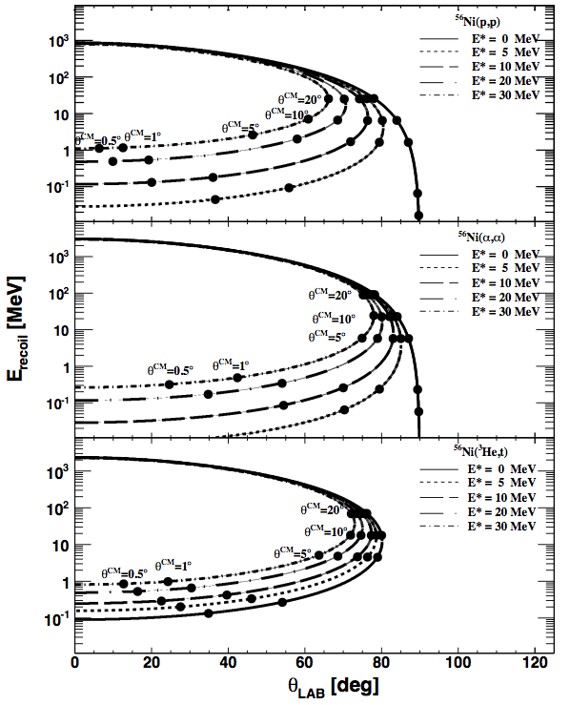

Figure 2: Inverse kinematics for various reactions on 56Ni at 200 MeV.

For the experiments we will use newly-manufactured DSSDs, the pockets positions (holding the detectors) are shown in Figure 3.

We will also use one of the two small pockets placed closer to the beam axis (Figure 1).

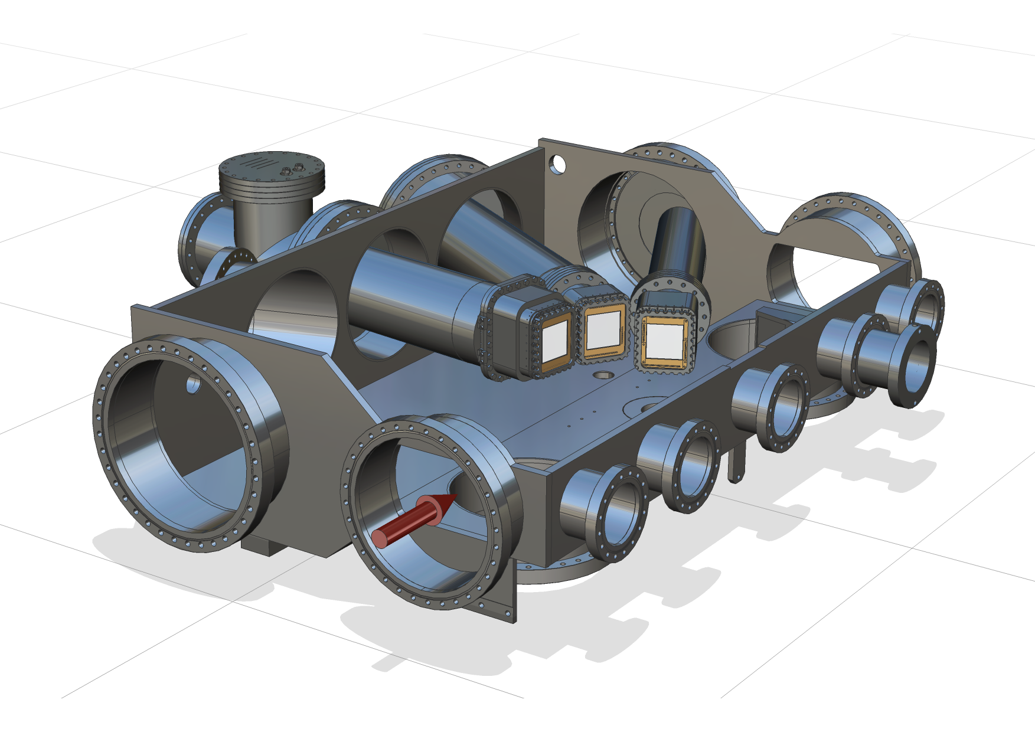

Figure 3: The schematic view of the scattering chamber with 3 large pockets placed around the target.

The setup is designed to fulfill the demanding UHV conditions at the storage ring. In addition to these detectors, a pocket with position-sensitive detectors will be placed downstream after the dipole magnets for the detection of the heavy ejectile ions. The position of these detectors is optimized to look at small momentum transfers for all the reactions of interest. We will also place detectors at small laboratory angles to look at emission of high-energy particles.